**Selamta - Software Development Plan**

http://bjohnson.lmu.build/cmsi401web/sdevplan.html

**4.1 Plan Introduction**

Our project involves creating a front-end for new patients who are joining a social clinic. The front-end will be populated by information unique to every patient through a series of radio buttons, text fields, and drop down menus. VPN access will be required to access any of the project components. The front-end will be connected to a backend MySQL database where users of the system can add, view, or edit any existing patient data.

4.1.1 Project Deliverables

Front-end with all required patient data - we will develop the frontend using React and host it on a lmu build webpage

Backend database - we are going to connect the frontend to a SQL database

VPN - we will have a VPN client installed on the laptop Selamta will use to access the data and a client installed on the host server

Project Proposal Document   
Initial Project Schedule

Requirements Specification Document (Initial)   
Software Development Plan Document (Initial)  
Software Development Plan Document (Updated)  
Requirements Specification Document (re-submit)

Preliminary Demonstration Presentations

FINAL Product Delivery (Final Report and Code)  
FINAL Project Presentation

**4.2 Project Resources**Basil - He will code the frontend and database integration.

Jordan - He will codie the front-end and connect it to the database.

Francesca - She will do the database design and code the rest of the project.

4.2.1 Hardware Resources

Category Requirement  
 ---------------- -----------------  
 Processor(CPU) Intel Core or Xeon 3GHz (or Dual Core 2GHz) or equal AMD CPU

Core Single  
 RAM 4 GB  
 Graphic Accelerators nVidia or ATI with support of OpenGL 1.5 or higher  
 Display Resolution 1280x1024

4.2.2 Software Resources

Atom - A hackable text editor for the 21st Century

React - A JavaScript library for building user interfaces

MySQL - The world's most popular open source database

**4.3 Project Organization**

Francesca will be doing the database design.

Jordan will be doing the front-end and back-end.

Basil will be doing the front-end and the backend.

**4.4 Project Schedule**

This section provides schedule information for the Selamta Client Management Project. The full details will be broken down into the following sections, which are described below.

Front end - next 3 weeks

Database design/structure - next 3 weeks

Front end to database connection - 3 weeks after front-end complete

VPN Encryption of Database - final week

4.4.1 PERT / GANTT Chart

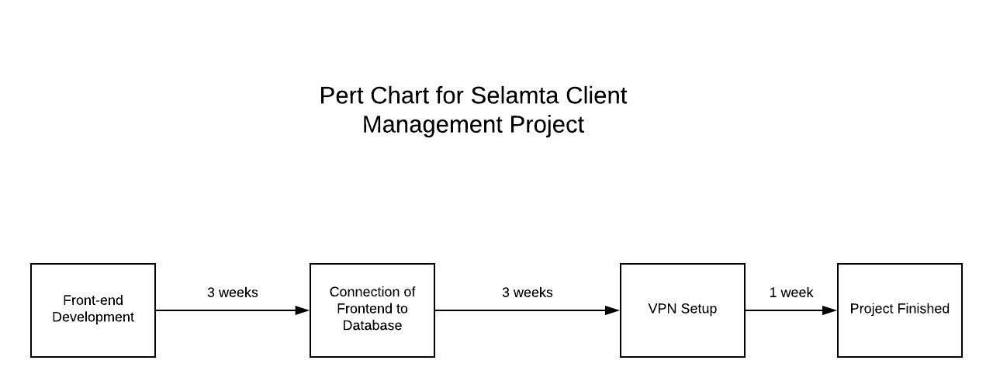  
4.4.2 Task / Resource Table

|  |  |  |  |
| --- | --- | --- | --- |
|  | Front-end | Database |  |
| People | Basl, Jordan | Francesca |  |
| Software | React | MySQL |  |
|  |  |  |  |